**Lab program 4: Singly Linked List Insert and display Implementation**

#include<stdio.h>  
#include<stdlib.h>  
struct node {  
    int data;  
    struct node *next;  
};  
struct node *head = NULL;  
void display() {  
    struct node *ptr = head;  
    if (ptr == NULL) {  
        printf("List is empty\n");  
        return;  
    }  
    printf("Elements are: ");  
    while (ptr != NULL) {  
        printf("%d ", ptr->data);  
        ptr = ptr->next;  
    }  
    printf("\n");  
}  
void insert_begin() {  
    struct node *temp;  
    temp = (struct node *)malloc(sizeof(struct node));  
    printf("Enter the value to be inserted: ");  
    scanf("%d", &temp->data);  
    temp->next = head;  
    head = temp;  
}  
void insert_end() {  
    struct node *temp, *ptr;  
    temp = (struct node *)malloc(sizeof(struct node));  
    printf("Enter the value to be inserted: ");  
    scanf("%d", &temp->data);  
    temp->next = NULL;  
    if (head == NULL) {  
        head = temp;  
    } else {  
        ptr = head;  
        while (ptr->next != NULL) {  
            ptr = ptr->next;  
        }  
        ptr->next = temp;  
    }  
}  
void insert_pos() {  
    int pos, i;  
    struct node *temp, *ptr;  
    temp = (struct node *)malloc(sizeof(struct node));  
    printf("Enter the position to insert: ");  
    scanf("%d", &pos);  
    printf("Enter the value to be inserted: ");  
    scanf("%d", &temp->data);  
    temp->next = NULL;  
  
    if (pos == 0) {  
        temp->next = head;  
        head = temp;  
    } else {  
        ptr = head;  
        for (i = 0; i < pos - 1; i++) {  
            ptr = ptr->next;  
            if (ptr == NULL) {  
                printf("Position not found\n");  
                return;  
            }  
        }  
        temp->next = ptr->next;  
        ptr->next = temp;  
    }  
}  
int main() {  
    int choice;  
    while(1) {  
        printf("\n1. Insert at the beginning\n2. Insert at the end\n3. Insert at any position\n4. Display\n5. Exit\n");  
        printf("Enter your choice: ");  
        scanf("%d", &choice);  
  
        switch(choice) {  
            case 1:  
                insert_begin();  
                break;  
            case 2:  
                insert_end();  
                break;  
            case 3:  
                insert_pos();  
                break;  
            case 4:  
                display();  
                break;  
            case 5:  
                exit(0);  
                break;  
            default:  
                printf("Enter the correct choice\n");  
        }  
    }  
    return 0;  
}

**Output**

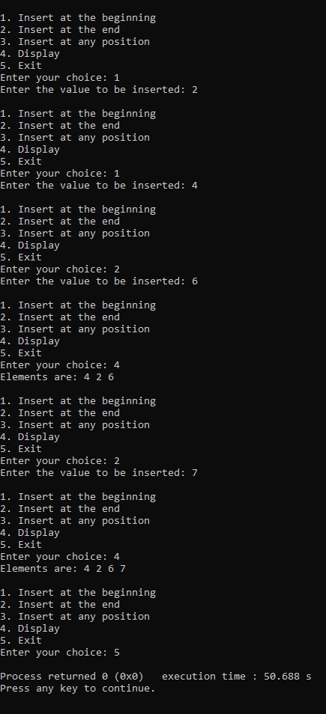

**Leet code- Min stack**

#include <stdlib.h>

typedef struct {

int *stack;

int *minStack;

int top

} MinStack;

MinStack* minStackCreate() {

MinStack* stack = (MinStack*)malloc(sizeof(MinStack));

stack->stack = (int*)malloc(sizeof(int) * 50);

stack->minStack = (int*)malloc(sizeof(int) * 50);

stack->top = -1;

return stack;

}

void minStackPush(MinStack* obj, int val) {

obj->top++;

obj->stack[obj->top] = val;

if (obj->top == 0 || val <= obj->minStack[obj->top - 1]) {

obj->minStack[obj->top] = val;

} else {

obj->minStack[obj->top] = obj->minStack[obj->top - 1];

}

}

void minStackPop(MinStack* obj) {

obj->top--;

}

int minStackTop(MinStack* obj) {

return obj->stack[obj->top];

}

int minStackGetMin(MinStack* obj) {

return obj->minStack[obj->top];

}

void minStackFree(MinStack* obj) {

free(obj->stack);

free(obj->minStack);

free(obj);

}

/**

 * Your MinStack struct will be instantiated and called as such:

 * MinStack* obj = minStackCreate();

* minStackPush(obj, val);

 * minStackPop(obj);

 * int param_3 = minStackTop(obj);

 * int param_4 = minStackGetMin(obj);

 * minStackFree(obj);

*/

**output**

